Experiment 1

Aim: Create a prototype with familiar and unfamiliar

navigation elements. Evaluate ease of use with

different user groups.

Materials Required: Pencil Project, Figma.

Procedure:

Step 1: Sign Up and Create a New Project

1. Go to figma.com and create an account (if you haven&#39;t already).

2. Once logged in, click &quot;New File&quot; to start a blank project.

3. You&#39;ll see a blank canvas where you can start designing.

Step 2: Create the Frame (Artboard)

1. On the left toolbar, select the &quot;Frame&quot; tool (shortcut: F).

2. Choose a mobile preset (e.g., iPhone 13) from the right-hand panel.

3. A mobile-sized frame will appear on the canvas, which will act as your app screen.

Step 3: Design the Login Screen

Add a Background Color:

1. Select the frame and go to the right-side panel.

2. Under &quot;Fill,&quot; choose a background color (e.g., light blue #E3F2FD).

Insert a Logo:

1. Click the &quot;Rectangle&quot; tool (shortcut: R) and draw a placeholder for a logo.

2. Use the &quot;Text&quot; tool (shortcut: T) to add your app name, e.g., &quot;MyApp&quot;.

3. Adjust font size and color from the right-hand panel.

Add Input Fields:

1. Use the &quot;Rectangle&quot; tool to draw two boxes for username and password fields.

2. Add placeholder text inside (e.g., &quot;Enter your email&quot;).

3. Apply rounded corners under &quot;Corner Radius&quot; in the right panel.

Add a Login Button:

1. Create a button using the &quot;Rectangle&quot; tool and set the color to blue (#1E88E5).

2. Use the &quot;Text&quot; tool to add the text &quot;Login&quot; inside the button.

3. Group the button and text together by selecting them and pressing Ctrl + G

(Windows) or Cmd + G (Mac).

Align Elements:

• Use the alignment tools in the top menu (center everything vertically and

horizontally).

• Adjust spacing between elements using the &quot;Auto Layout&quot; feature (Shift + A).

Step 4: Prototyping the Interaction

1. Click the &quot;Prototype&quot; tab on the right panel.

2. Select the &quot;Login&quot; button and drag the blue dot to a new frame (e.g., a home

screen).

3. Set the interaction to &quot;On Click&quot; → &quot;Navigate to&quot; the next screen.

4. Choose an animation effect (e.g., &quot;Smart Animate&quot;).

Step 5: Preview the Design

1. Click the &quot;Play&quot; button in the top-right corner to preview your app prototype.

2. Try clicking on the login button to see the transition to the next screen.

Step 6: Share Your Design

1. Click the &quot;Share&quot; button in the top-right corner.

2. You can invite team members via email or generate a shareable link.

3. Adjust permissions (View, Edit, or Comment only).

Step 7: Export Assets

1. Select the elements you want to export (e.g., the logo or button).

2. In the right-hand panel, click &quot;Export&quot; and choose a format (PNG, JPG, SVG).

3. Click &quot;Export&quot; to download assets for developers.

Output:

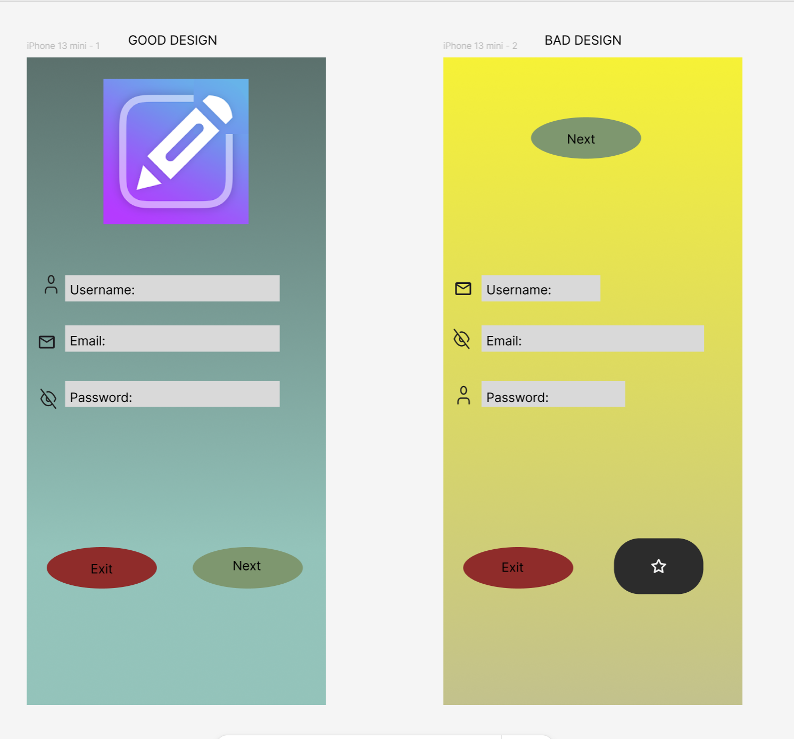

Explanation:

The reason is because, in the first design the buttons and the app logo is placed correctly and the distance between each button is equal. In the second design the app logo and the buttons are placed incorrectly and the icons for the fill ups box and the size of the box is different.

Result:

The design of prototype with familiar and unfamiliar

navigation elements and Evaluating the ease of use with

different user groups is successfully designed.